SQL PROJECT

I. Import the dataset and do usual exploratory analysis steps like checking the structure &
Characteristics of the dataset:

A. Data type of all columns in the “customers” table:

SELECT
column_name ,data_type
FROM `sql-469709.ecommerce_db`.INFORMATION_SCHEMA.COLUMNS
WHERE table_name = 'customers';

Results:

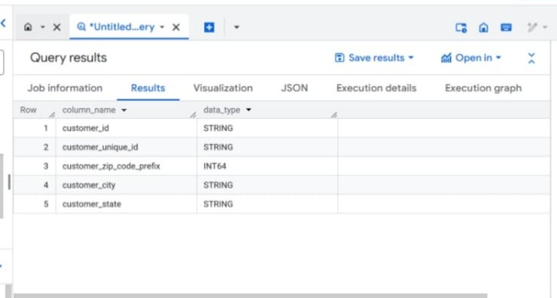

B. Get the time range between which the orders were placed:

SELECT MIN(order_purchase_timestamp) AS first_order_time,
MAX(order_purchase_timestamp)AS last_order_time
FROM
`sql-469709.ecommerce_db.orders`;

Results:
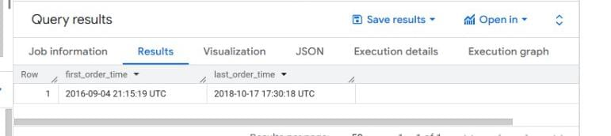

C.Count the Cities & States of customers who ordered during the given period:
SELECT
customers.customer_id,customers.customer_city,
customer.customer_state,orders.order_purchase_timestamp
FROM
ecommerce_db.customers JOIN ecommerce_db.orders ON
customers.customer_id=orders.customer_id
WHERE orders.order_purchase_timestamp BETWEEN
"2016-09-04"and"2018-10-17";

Results:

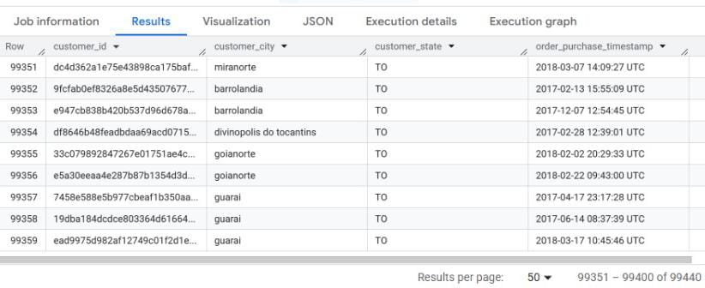

II. In-depth Exploration:

A. Is there a growing trend in the no. of orders placed over the past years:

SELECT
DATE_TRUNC(order_purchase_timestamp,month)AS month,
COUNT(order_id)AS total_orders
FROM `ecommerce_db.orders` GROUP BY month order by month;

Results:
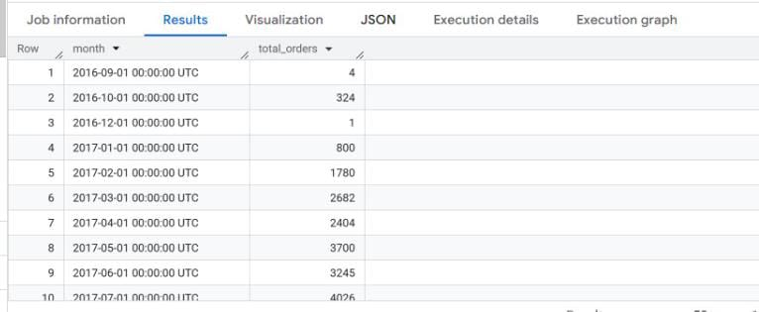

B. Can we see some kind of monthly seasonality in terms of the no.of orders being placed:

SELECT EXTRACT(month from order_purchase_timestamp) AS MONTH,
COUNT(order_id)AS total_orders
FROM `ecommerce_db.orders`
GROUP BY month
ORDER BY month;

Results:

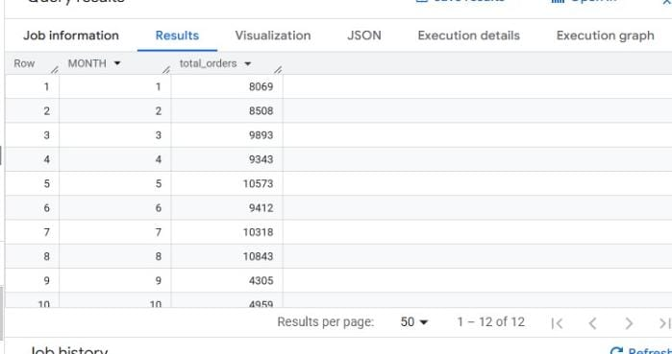

C. During what time of the day,do the Brazilian customers mostly place their orders?
(Dawn,Morning,Afternoon or Night)

- 0-6 hrs : Dawn
- 7-12 hrs : Mornings
- 13-18 hrs : Afternoon
- 19-23 hrs : Night
SELECT
CASE
WHEN EXTRACT(hour FROM order_purchase_timestamp)BETWEEN 0 AND 6 THEN 'Dawn'
WHEN EXTRACT(hour FROM order_purchase_timestamp)BETWEEN 7 AND 12 THEN 'Morning'
WHEN EXTRACT(hour FROM order_purchase_timestamp)BETWEEN 13 AND 18 THEN 'Afternoon'
ELSE 'Night'
END AS time_of_day,
COUNT(order_id)AS total_orders
FROM `ecommerce_db.orders`
GROUP BY time_of_day
ORDER BY total_orders DESC;

Results:

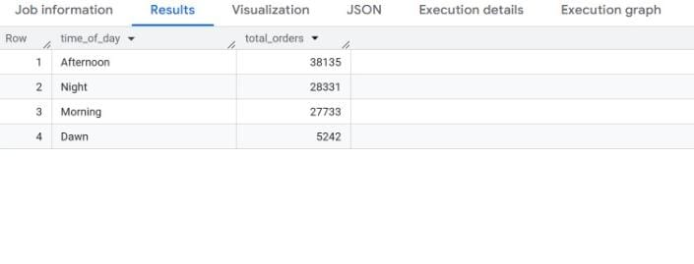

III. Evolution of E-commerce orders in the Brazil region:

A. Get the month on month no.of orders placed in each state:

SELECT
C.Customer_state,
DATE_TRUNC(o.order_purchase_timestamp,month)AS month,
COUNT(o.order_id)AS total_orders
FROM `ecommerce_db.orders`AS O JOIN
`ecommerce_db.customers` AS C ON O.customer_id=C.customer_id
GROUP BY C.customer_state,month
ORDER BY month,total_orders DESC;

Results:

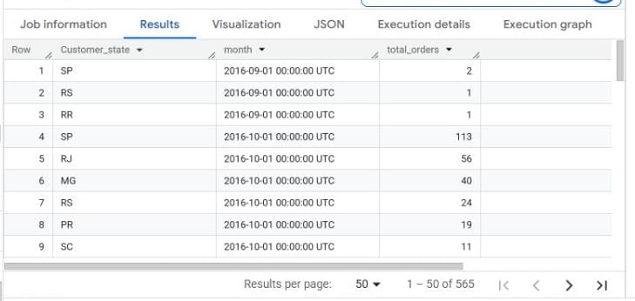

B. How are the customrs distributed across all the states:

SELECT
customer_state,COUNT(DISTINCT customer_id)AS unique_customers
FROM `ecommerce_db.customers`
GROUP BY customer_state
ORDER BY unique_customers DESC;

Results:

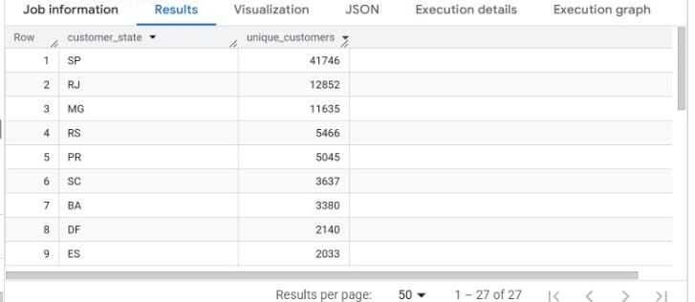

IV. Impact on Economy : Analyze the money movement by e-commerce by looking at order prices,
Freight and others:

A. Get the % increase in the cost of orders from year 2017 to 2018:
(include months between Jan to Aug only)

WITH yearly_cost AS(SELECT EXTRACT(YEAR FROM O.order_purchase_timestamp)AS
year,SUM(p.payment_value)AS total_cost
FROM `ecommerce_db.orders` O JOIN `ecommerce_db.payments`
P ON O.order_id=P.order_id
WHERE EXTRACT(month FROM O.order_purchase_timestamp)
BETWEEN 1 AND 8 GROUP BY year)
SELECT((MAX(CASE WHEN year=2018 THEN total_cost END)-MAX(CASE WHEN year=2017 THEN
total_cost END))/MAX(CASE WHEN year=2017 THEN total_cost END))*100
AS pct_increase FROM yearly_cost;

Results:

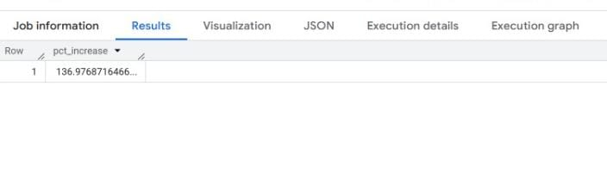

B. Calculate the Total & Average value of order price for each state:

WITH order_totals AS (SELECT o.order_id,c.customer_state,
SUM(oi.price+oi.freight_value)
AS order_value FROM `ecommerce_db.orders`
O JOIN `ecommerce_db.customers` C ON
O.customer_id=C.customer_id JOIN `ecommerce_db.order_items`
oi ON O.order_id=O.order_id
GROUP BY O.order_id,C.customer_state)
SELECT Customer_state,SUM(order_value)AS total_order_value,
AVG(order_value)AS avg_order_value
FROM order_totals
GROUP BY customer_state
ORDER BY total_order_value DESC;

Results:

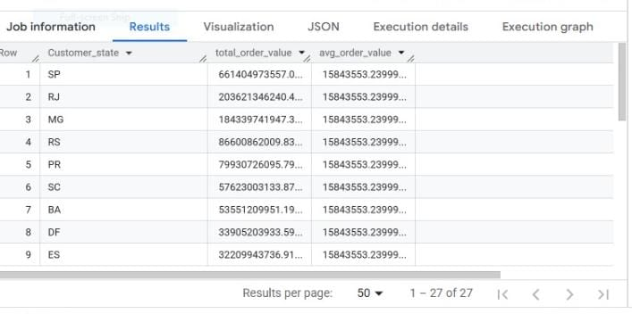

C. Calculate the Total & Average value of order freight for each state:

SELECT c.customer_state,SUM(oi.freight_value)AS total_freight,
AVG(oi.freight_value)AS avg_freight
FROM `ecommerce_db.orders` O JOIN `ecommerce_db.customers` C
ON O.customer_id=C.customer_id JOIN `ecommerce_db.order_items` oi
ON O.order_id=oi.order_id
GROUP BY C.customer_state
ORDER BY total_freight DESC;

Results:
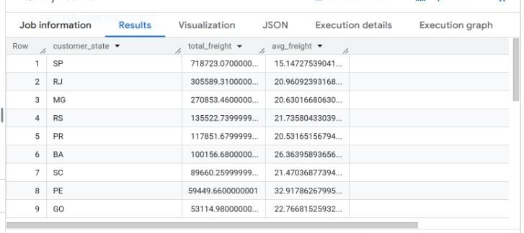

V. Analysis based on sales , freight and delivery time:
A. Find the no. of days taken to deliver each order from the orders purchase date as delivery time. Also, calculate the difference (in days) between the estimated & actual delivery date of an order. Do this in a single query:

SELECT o.order_id,DATE_DIFF(o.order_delivered_customer_date,o.order_purchase_timestamp,day)
AS time_to_deliver,DATE_DIFF(o.order_estimated_delivery_date,
o.order_delivered_customer_date,day)AS diff_estimated_delivery
FROM `ecommerce_db.orders` o
WHERE o.order_delivered_customer_date IS NOT NULL;

Results:

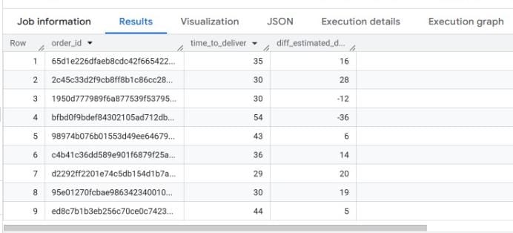

B. Find out the top 5 sttes with the highet & lowest aerage freight value:

WITH freight_per_state AS(
SELECT c.customer_state,
AVG(oi.freight_value)AS avg_freight
FROM `ecommerce_db.orders` o
JOIN `ecommerce_db.order_items` oi ON o.order_id=oi.order_id
JOIN `ecommerce_db.customers` c ON o.customer_id= c.customer_id
GROUP BY c.customer_state),
top_5 AS(
SELECT * FROM freight_per_state
ORDER BY avg_freight DESC
LIMIT 5),
bottom_5 AS (
SELECT* FROM freight_per_state
ORDER BY avg_freight ASC
LIMIT 5)
SELECT * FROM top_5 UNION ALL SELECT*FROM bottom_5;

Results:

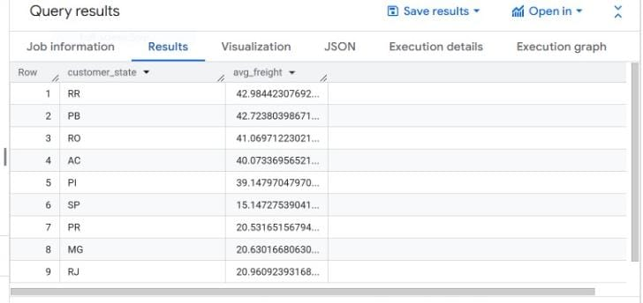

C. Find out the top 5 states with the hightest & lowest average delivery time:

WITH delivery_time AS
(
SELECT
o.order_id,
c.customer_id,
c.customer_state,
DATE_DIFF(o.order_delivered_customer_date,o.order_purchase_timestamp, DAY)AS delivery_days
FROM `ecommerce_db.orders` o
JOIN `ecommerce_db.customers` c
ON o.customer_id=c.customer_id
WHERE o.order_delivered_customer_date IS NOT NULL
),
average_delivery AS
(
SELECT customer_state,
AVG(delivery_days)AS avg_delivery
FROM delivery_time
GROUP BY customer_state),
top_5 AS(
SELECT *
FROM average_delivery
ORDER BY avg_delivery DESC
LIMIT 5
),
bottom_5 AS
(
SELECT *
FROM average_delivery
ORDER BY avg_delivery ASC
LIMIT 5)
SELECT *FROM top_5 UNION all SELECT * FROM bottom_5

Results:

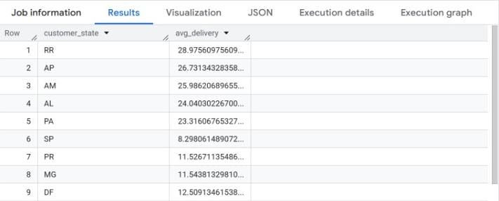

D. Find out the top 5 states where the order delivery is really fast as compared to the estimated date of delivery:

WITH delivery_diff AS(
SELECT c.customer_state,
DATE_DIFF(o.order_estimated_delivery_date, o.order_delivered_customer_date,DAY)AS
early_by_days
FROM ecommerce_db.orders o
JOIN `ecommerce_db.customers` c ON o.customer_id=c.customer_id
WHERE o.order_delivered_customer_date IS NOT NULL)
SELECT customer_state,AVG(early_by_days)AS avg_early_delivery
FROM delivery_diff
GROUP BY customer_state
ORDER BY avg_early_delivery DESC
LIMIT 5;

Results:

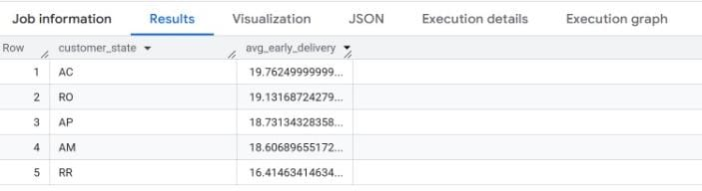

VI. Analysis based on the payments:

A. Find the month on month no. of orders placed using different payment type:

SELECT FORMAT_TIMESTAMP('%Y-%M',o.order_purchase_timestamp)AS
order_month,p.payment_type,
COUNT(DISTINCT o.order_id)AS num_orders
FROM ecommerce_db.orders o
JOIN ecommerce_db.payments p
ON o.order_id=p.order_id
GROUP BY order_month,p.payment_type
ORDER BY order_month,p.payment_type;

Result:

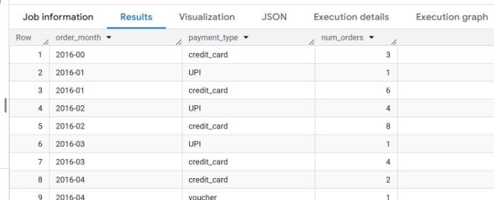

B. Find the o. of orders placed on the basic of the payment instalments that have been paid:

SELECT
p.payment_installments,
COUNT(DISTINCT p.order_id)AS num_orders
FROM ecommerce_db.payments p
WHERE p.payment_installments >=1
GROUP BY p.payment_installments
ORDER BY p.payment_installments;

Results:

